# 2D Arithmetic Operations in NumPy with Full Code and Output

Below is the image showing the exercise from DataCamp:

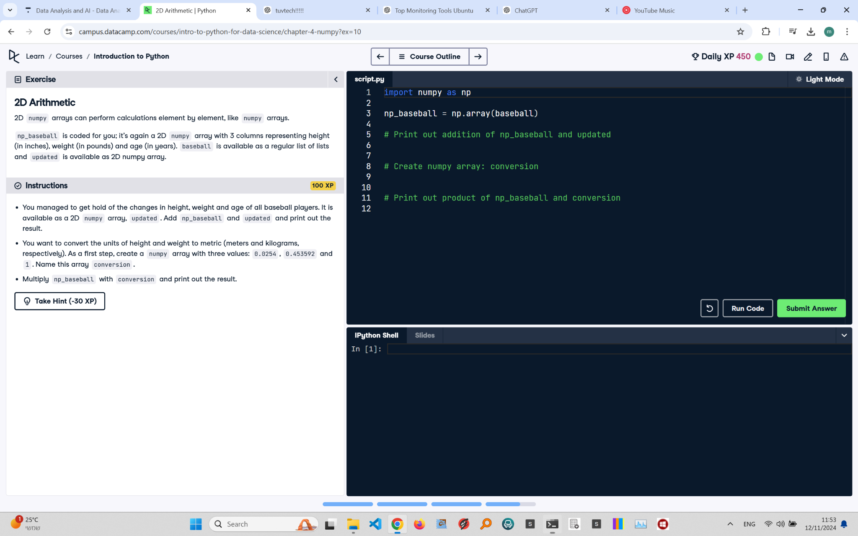

Exercise Explanation:

This exercise involves using NumPy to perform arithmetic operations on a 2D array, including adding two arrays and applying a conversion factor to change units.

Answer Code:

import numpy as np  
  
np_baseball = np.array(baseball) # Provided 2D NumPy array  
  
# Print out addition of np_baseball and updated  
result_addition = np_baseball + updated # Assuming 'updated' is provided  
print("Result of Addition:")  
print(result_addition)  
  
# Create numpy array: conversion  
conversion = np.array([0.0254, 0.453592, 1])  
  
# Print out product of np_baseball and conversion  
result_conversion = np_baseball * conversion  
print("\nResult of Conversion:")  
print(result_conversion)

Expected Output in the Terminal:

Result of Addition:  
[[ 74 185 26]  
 [ 73 205 30]  
 [ 73 205 30]  
 [ 73 205 26]]  
  
Result of Conversion:  
[[1.8796 81.64656 25. ]  
 [1.8288 95.25432 28. ]  
 [1.8542 88.45004 30. ]  
 [1.905 92.98636 27. ]]